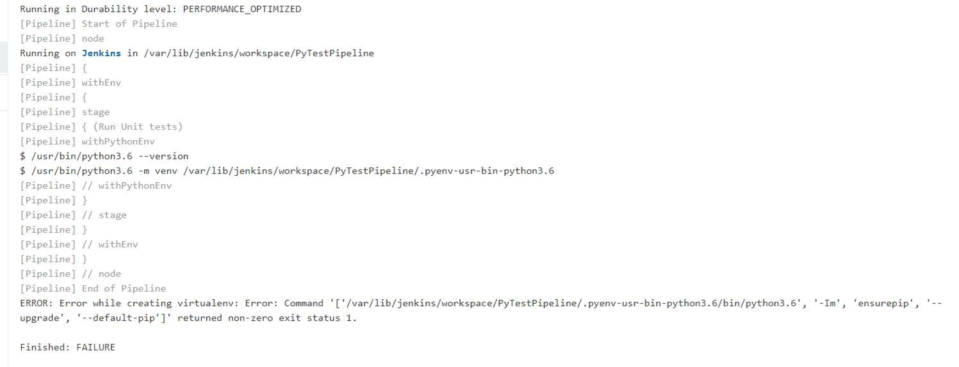

Sample code
pipeline
{

agent any

environment
{

PY_VENV= '/var/lib/jenkins/python-env/venv/bin/'

}

stages {

stage('Run Unit tests')
{
steps
{
withPythonEnv('/usr/bin/python3.6')
{
echo ‘****** virtual env for test******* '
sh 'pytest test_squareRoot.py'
} //withPythonEnv
}//steps

/* post {
always {
echo 'Test 2 *******************generating reports***********'
// Archive unit tests for the future
junit (allowEmptyResults: true,
testResults: './reports/unit_tests.xml')
}
}*/

} //stage
}//stages
}//pipeline

